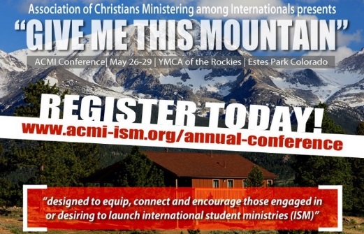

The 2016 Conference Committee is planning childcare during the conference for children of the following ages:
- Nursery to age 5
- Ages 6 to 12
Teenagers are welcome to come to the YMCA of the Rockies with their parents, but are not included in the conference childcare plans and would be somewhat on their own (or they could help out with the little kids!).
This link will show you some of the activities that will be available: http://ymcarockies.org/activities/
The childcare workers will be adult and teenage childcare providers, and available at the following times:
- Thursday (5/26) 7:15pm-9pm
- Friday (5/27) 8am-Noon; 7:15pm-8:30pm
- Saturday (5/28) 8am-Noon; 1:30pm-5pm; 7:15pm-9pm
The YMCA of the Rockies offers lots of activities on site, some of them for free. Activities like swimming, hiking, etc. will be used during the stated childcare times. We will know more when the May schedule of activities comes out. It is important for you to fill out the form on the second page so we will know what is appropriate for your kiddos.
Plan to pack:
- Swimsuit, cover up and towel
- Sweatpants and shorts
- Sunscreen
- Tennis shoes, light jacket, sweatshirt, flip flops

Children will eat all meals with parents. All free time activities will be with parents as well. You can take advantage of the activities or do your own thing.

Please complete and save the form below; then email it to Conference Director Michelle Williams

(Please fill out one form for each child because they may be with different child care providers)

2016 Conference Child Care Registration Form

Date of stay ____________________________

Child’s Name: _____________________________________________________ Gender: Male / Female

Date of Birth: ___________________________ Age: ____________ Grade for 2016/2017 school year ______

Parent/Guardian Full Name: __________________________________________________________________

Cell Phone during the conference __________________________ Email: ______________________________
Is it ok to text during the conference? Yes /No

Allergies: _________________________________________________________________________________

Other Concerns (medical, special needs, etc): ______________________________________________________

I am staying in the _______________________________________ Room # _______________________________

